DEAN FACULTY SECRETARY
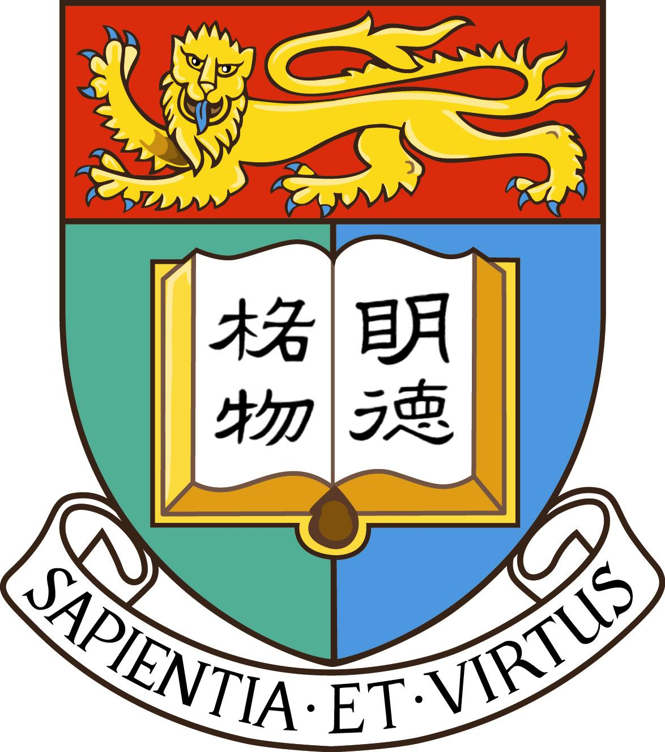
Professor S Kwok Mrs. A O M Tsang
院長 郭新教授 院務主任 曾謝靄文女士

FACULTY OF SCIENCE
THE UNIVERSITY OF HONG KONG
香港大學 理學院

Sponsorship Form for the HKU Science and Art Crossover Project

- I am

an HKU Alumni Year: Program:

not an HKU Alumni, but would like to be a sponsor

- I would like to sponsor

Platinum Sponsor: $5,000 or above Gold Sponsor: $2,000 or above

Silver Sponsor: $1,000 or above Bronze Sponsor: $500 or above

Copper Sponsor: $100 or above Other: $

Or materials/service/souvenirs in equivalent value
Please specific item and quantity:
Food & Drinks:

Workshop Materials:

Transportation Service:

Souvenirs:

Others:

- Contact information (All data will be treated in strict confidence)
Sponsor’s name in English:

Contact number:

E-mail:

Address:

- Ways to Donate
By Direct Transfer

You can direct transfer to either of the following bank accounts of “The University of Hong Kong”
HSBC: 004-502-403421-001
Bank of East Asia: 015-176-25-00683-0
Please e-mail (ngbenny@hku.hk) or mail your bank deposit receipt or the online transfer confirmation page together with this sponsorship form.

By Crossed Cheque
Please make cheque payable to: “The University of Hong Kong” and send the cheque together with this donation form to Faculty of Science, G/F, Chong Yuet Ming Physics Building, The University of Hong Kong, Pokfulam Road, Hong Kong.

- Inquiry

Please call 3917 4594, fax 2858 4620 or email to ngbenny@hku.hk for enquiry

Pokfulam Road Tel: (852) 2859 2683 Fax: (852) 2858 4620 E-mail: science@hku.hk Website: http://www.hku.hk/science

